**Question No: 01**

#include <stdio.h>

#include <math.h>

int main() {

    // Declare variables

    Double initial_population,percentage_increase,known_time,target_time,growth_rate,calculated_population;

    printf("Enter the initial population: ");

    scanf("%lf", &initial_population);

    printf("Enter the percentage increase (e.g., 35 for 35%%): ");

    scanf("%lf", &percentage_increase);

    printf("Enter the time period for the percentage increase (in years): ");

    scanf("%lf", &known_time);

    printf("Enter the time for which to calculate the population (in years): ");

    scanf("%lf", &target_time);

    // Calculate the population after the known time

    double population_after_known_time = initial_population * (1 + percentage_increase / 100);

    // Calculate growth rate (k)

    growth_rate = log(population_after_known_time / initial_population) / known_time;

    // Calculate the population after the target time

    calculated_population = initial_population * exp(growth_rate * target_time);

    //result

    printf("The population after %.2f years will be approximately %.2f\n", target_time, calculated_population);

    return 0;

}

**Output:**

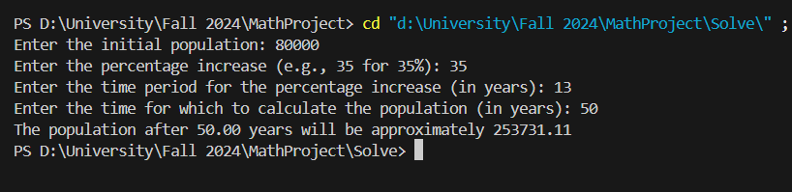

**Question No: 02**

#include <stdio.h>

#include <math.h>

int main() {

    double Enviroment_temp, initial_temp, temp_after_1_min, time, cooling_constant, final_temp;

    printf("Enter the Enviroment temperature (in Celsius): ");

    scanf("%lf", &Enviroment_temp);

    printf("Enter the initial temperature of the body (in Celsius): ");

    scanf("%lf", &initial_temp);

    printf("Enter the temperature of the body after 1 minute (in Celsius): ");

    scanf("%lf", &temp_after_1_min);

    printf("Enter the time in minutes for which to calculate the temperature: ");

    scanf("%lf", &time);

    // Validate input

    if (initial_temp <= Enviroment_temp || temp_after_1_min <= Enviroment_temp || temp_after_1_min >= initial_temp) {

        printf("Error: Input values must satisfy initial_temp > temp_after_1_min > Enviroment_temp.\n");

        return 1;

    }

    //Calculate the cooling constant (k)

    cooling_constant = -log((temp_after_1_min - Enviroment_temp) / (initial_temp - Enviroment_temp));

    //Calculate the temperature at the given time

    final_temp = Enviroment_temp + (initial_temp - Enviroment_temp) * exp(-cooling_constant * time);

    //result

    printf("The temperature of the body at the end of %.2lf minutes is %.2lfC\n", time, final_temp);

    return 0;

}

**Output:**

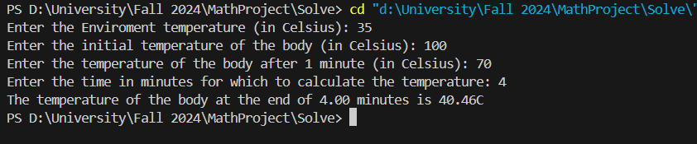

**Question No: 03**

#include <stdio.h>

#include <math.h>

int main() {

    double total_S, S_converted, t1, t2, S_total_converted;

    printf("Enter the amount of sugar (grams): ");

    scanf("%lf", &total_S);

    printf("Enter the amount converted in time t1 (grams): ");

    scanf("%lf", &S_converted);

    printf("Enter the time t1 (min): ");

    scanf("%lf", &t1);

    printf("Enter the time to find the conversion (min): ");

    scanf("%lf", &t2);

    double k = -log(1 - S_converted / total_S) / t1;

    S_total_converted = total_S * (1 - exp(-k * t2)); // exp -> e to the power -k*t2

    printf("%.2lf",k);

    printf("The total amount converted in %.2lf minutes is %.2lf grams\n", t2, S_total_converted);

    return 0;

}

**Output:**

